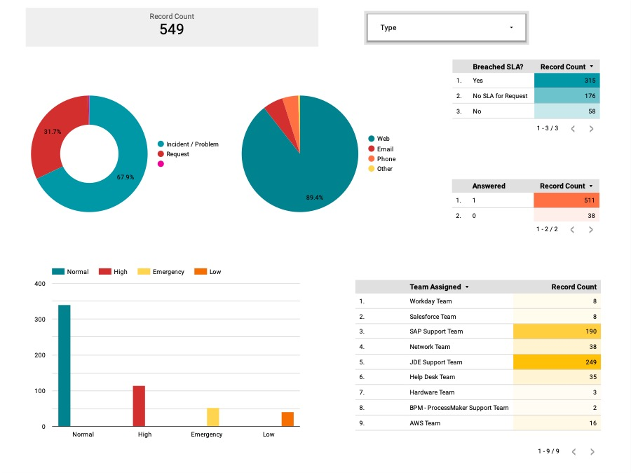

**Total Records**: 549

**Record Count Distribution by Type:**

Incident/Problem: 31.7%

Request: 67.9%

**Type Distribution by Breached SLA:**

Yes (SLA Breached): 315 records

No SLA for Request: 176 records

No (SLA Not Breached): 58 records

**Communication Channel for Queries:**

Web: 89.4%

Other Channels:

Email: (Specific percentage not shown in the graph)

Phone: (Specific percentage not shown in the graph)

Other: (Specific percentage not shown in the graph)

**Status of Answers:**

Answered: 511 records

Not Answered: 38 records

**Distribution of Record Priority:**

Normal: Approximately 400 records

High: Roughly 50 records

Emergency: About 25 records

Low: Close to 75 records

**Team Assignment Distribution:**

JDE Support Team: 249 records

SAP Support Team: 190 records

Network Team: 38 records

Help Desk Team: 35 records

AWS Team: 16 records

Workday Team: 8 records

Salesforce Team: 8 records

Hardware Team: 3 records

BPM- ProcessMaker Support Team: 2 records